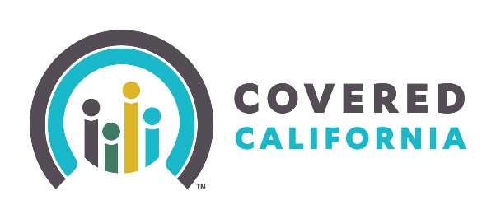

Email Copy

From: DHCS or counties. To: Ineligible Medi-Cal population
Subject: Covered California: If you are losing Medi-Cal
Display Text: You have 60 days to enroll in Covered California!

Dear XXXX,
You may be eligible for health coverage through Covered California if you are no longer eligible for Medi-Cal due to an income increase or change in household size. In order to avoid a gap in your health coverage, Covered California can help you select a new plan before your Medi-Cal coverage ends.
Covered California offers a choice of many quality health plans such as Anthem Blue Cross, Kaiser, Blue Shield, Molina, and Health Net. Many of these plans are more affordable than you might think - 4 out of 5 Covered California members receive financial help paying for their health insurance!
Covered California can help get you enrolled. You must act fast as you only have 60 days from the date of losing Medi-Cal eligibility to enroll in Covered California through the special enrollment period. This 60 day window allows you to enroll in a plan outside of open enrollment, which occurs at the end of each year. Call an expert or find free local help today!
Call today: 800-920-1125
Monday - Friday 8 a.m. - 6 p.m.
OR
Find a free certified enrollment counselor to speak with:
http://www.coveredca.com/get-help/local
How do I qualify for financial help with Covered California?
Financial help, in the form of Advanced Premium Tax Credits (APTC), can lower the cost of health care for individuals and families who enroll in a health plan through Covered California and meet certain income requirements. For more information, please see the video here.

More questions?
Call Covered California at (800) 920-1125, Monday - Friday 8 a.m. - 6 p.m.

Speak with a free certified enrollment expert here: http://www.coveredca.com/get-help/local/

Contact Covered California through Facebook and Twitter

NOTE: If you believe you have received this message in error, please contact your county human services agency.

